**Stereochemistry of Alkene Additions: addition of Bromine to *trans-*Cinnamic Acid**

**Observations**

* 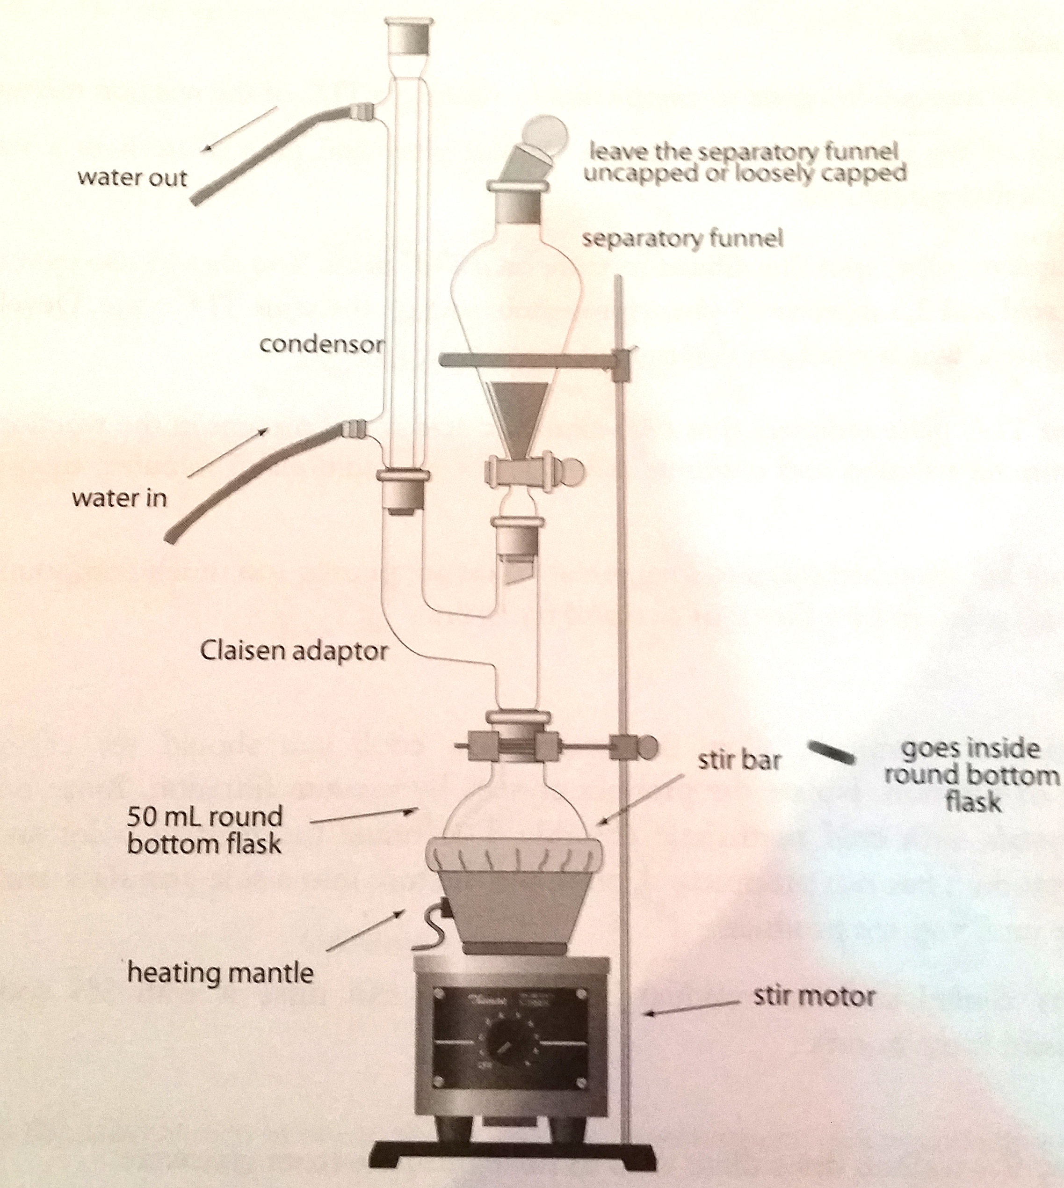
* It was a little unclear to me when and how much with what amount were we supposed to add Bromine.
* I let it run for around 20 minutes in total as I wasn’t sure that I had to add all the bromine, thus it ran for another 10 minutes after the 10 minute line (when bromine was added).
* Also when the bromine was added to the apparatus, it was added a little too fast. Thus the bromine color came up to the claisen adaptor. I’m not sure if that had any effect on the percent yield or the efficiency of the whole lab experiment. Thus, I did a second trial and recycled all the data of the first trial.

**Calculations**

* Melting point (Product) : 201-203 oC
* Percent yield:
  + of 2,3-dibromo-3-phenylpropanoicacid

**Discussion and Results**

In conclusion, this lab perfectly administered the method of refluxing to perform an addition reaction. Refluxing was necessary for this reaction to provide energy, allowing it to react at fair rate with the heat, increasing the rate of reaction and the magnetic stirrer allowing it to be more efficient. However, the percent yield seemed to be fairly low for this reaction, at 10.01%, due to the fact that all the trans-cinnamic acid was removed from the system, with the TLC test being the evidence of it. Maybe, some gaseous trans-cinnamic acid escaped the hood while the perfect temperature for reflux was being established. In addition, while cleaning the glassware at the end of the lab experiment, the sides of the glassware had some substance left, which quiet possibly could be the remaining trans-cinnamic acid. Various different eluting solvent systems were run with the TLC plates while reflux was occurring, so that the system that separates the standards the best suitable would be run with the final product. Depending on the mix of solvents with different concentrations of ethyl acetate and hexanes, the TLC plate will have the different standards climb to different heights. If a solvent is more polar, it is more likely to absorb the polar surface of the TLC plate in place of the compounds being spotted. That would allow the spotted compounds to climb higher on the TLC plate. The solvent mixture that qualitatively worked the best in this lab was the 70:30 mixture of ethyl acetate to hexane. The final TLC was run with 70:30 solvent as that is what I felt had the clearest separation of the two standards, and it indicated that there was no more trans-cinnamic acid in the reaction pot, as per the drawing in the data section. Finding the melting point of the product was another method of confirming the identity and conformation of 2,3-dibromo-3-phenylpropanoicacid. As my measured melting point is 201-203 degrees Celsius, the conformation is erythro, as the literature melting point value is 202-204 degrees Celsius for it. Given this information, the recovered sample appears to be fairly pure, falling within the literature value for melting point of the erythro product. The objective of this lab was accomplished.